Week-3 Assignment
Mini CRUD Project – User Manager
Features
Add user
Display users
Edit user
Delete user
- Below is the default page that should load.

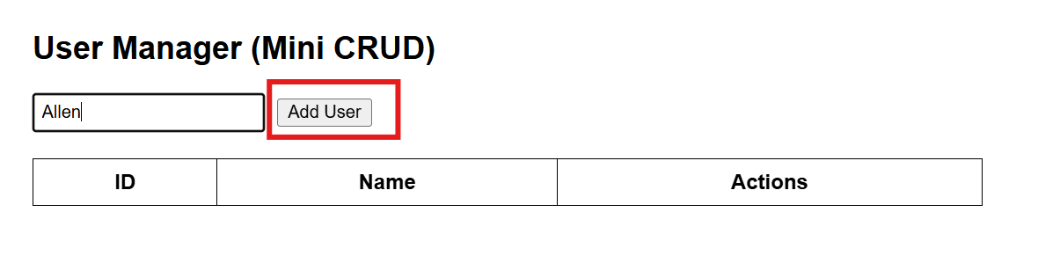

- When the user types a name in the text field and clicks on the Add User button, the name should be added to the table.

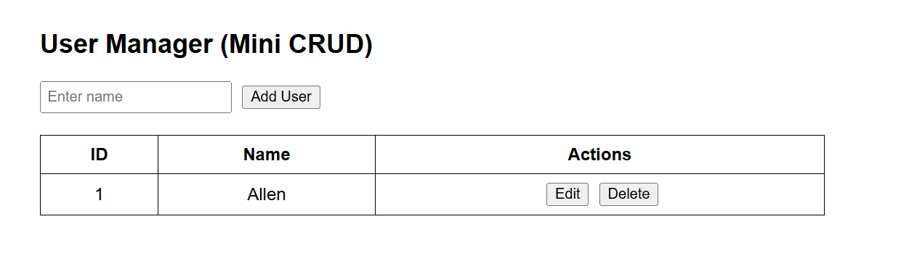

3. When the user clicks on the Edit button, it should display the screen shown below.

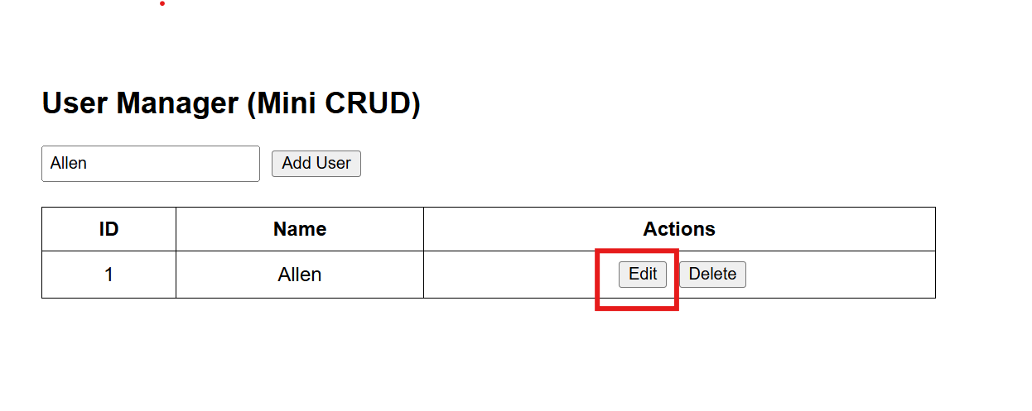

4. The user should then change the text (for example, replace Allen with Black), and the table should be updated as shown in the screen below.

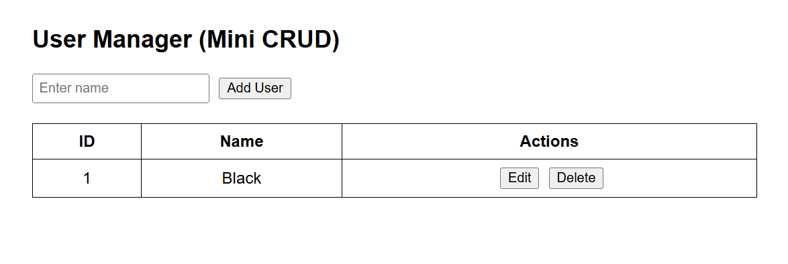
- When the user clicks on the Delete button, the user should be removed from the table as shown in the screen below.

